Factor Analysis

Notes
Output Created |  | 28-JUN-2021 14:10:56
Comments
Input | Active Dataset | DataSet61
Input | Filter | <none>
Input | Weight | <none>
Input | Split File | <none>
Input | N of Rows in Working Data File | 275
Missing Value Handling | Definition of Missing | MISSING=EXCLUDE: User-defined missing values are treated as missing.
Missing Value Handling | Cases Used | LISTWISE: Statistics are based on cases with no missing values for any variable used.
Syntax |  | FACTOR  /VARIABLES ZConfirmed ZDeaths ZRecovered  /MISSING LISTWISE  /ANALYSIS ZConfirmed ZDeaths ZRecovered  /PRINT UNIVARIATE INITIAL CORRELATION EXTRACTION ROTATION  /FORMAT SORT  /PLOT EIGEN  /CRITERIA FACTORS(3) ITERATE(25)  /EXTRACTION PC  /CRITERIA ITERATE(25)  /ROTATION VARIMAX  /METHOD=COVARIANCE.
Resources | Processor Time | 00:00:00.22
Resources | Elapsed Time | 00:00:00.25
Resources | Maximum Memory Required | 1984 (1.938K) bytes

[DataSet61]

Descriptive Statistics
 | Mean | Std. Deviation | Analysis N
ZConfirmed | .92005967 | .999999829 | 91
ZDeaths | .85354000 | .999999119 | 91
ZRecovered | .72601077 | .999999053 | 91

Correlation Matrix
 |  | ZConfirmed | ZDeaths | ZRecovered
Correlation | ZConfirmed | 1.000 | .996 | .946
Correlation | ZDeaths | .996 | 1.000 | .965
Correlation | ZRecovered | .946 | .965 | 1.000

Communalities
 | Raw |  | Rescaled
 | Initial | Extraction | Initial | Extraction
ZConfirmed | 1.000 | 1.000 | 1.000 | 1.000
ZDeaths | 1.000 | 1.000 | 1.000 | 1.000
ZRecovered | 1.000 | 1.000 | 1.000 | 1.000

Extraction Method: Principal Component Analysis.

Total Variance Explained
 | Component | Initial Eigenvaluesª |  |  | Extraction Sums of Squared Loadings
 | Component | Total | % of Variance | Cumulative % | Total | % of Variance
Raw | 1 | 2.938 | 97.945 | 97.945 | 2.938 | 97.945
Raw | 2 | .060 | 2.002 | 99.947 | .060 | 2.002
Raw | 3 | .002 | .053 | 100.000 | .002 | .053
Rescaled | 1 | 2.938 | 97.945 | 97.945 | 2.938 | 97.945
Rescaled | 2 | .060 | 2.002 | 99.947 | .060 | 2.002
Rescaled | 3 | .002 | .053 | 100.000 | .002 | .053

Total Variance Explained
 | Component | Extraction Sums of Squared Loadingsª | Rotation Sums of Squared Loadings
 | Component | Cumulative % | Total | % of Variance | Cumulative %
Raw | 1 | 97.945 | 1.623 | 54.114 | 54.114
Raw | 2 | 99.947 | 1.375 | 45.824 | 99.938
Raw | 3 | 100.000 | .002 | .062 | 100.000
Rescaled | 1 | 97.945 | 1.623 | 54.114 | 54.114
Rescaled | 2 | 99.947 | 1.375 | 45.824 | 99.938
Rescaled | 3 | 100.000 | .002 | .062 | 100.000

Extraction Method: Principal Component Analysis.
a. When analyzing a covariance matrix, the initial eigenvalues are the same across the raw and rescaled solution.

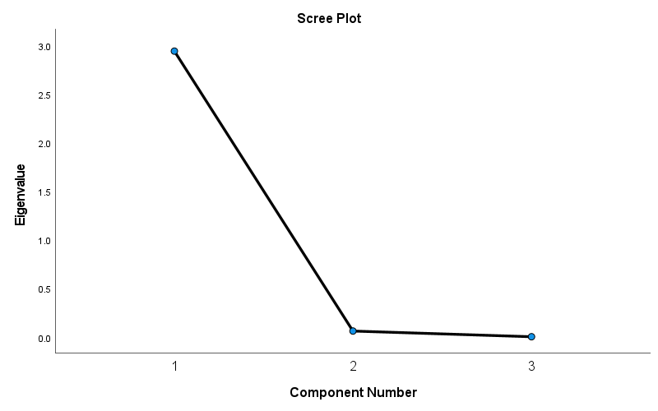

Component Matrixª
 | Raw |  |  | Rescaled
 | Component |  |  | Component
 | 1 | 2 | 3 | 1 | 2 | 3
ZDeaths | .997 | -.065 | -.031 | .997 | -.065 | -.031
ZConfirmed | .991 | -.130 | .025 | .991 | -.130 | .025
ZRecovered | .980 | .197 | .006 | .980 | .197 | .006

Extraction Method: Principal Component Analysis.ª
a. 3 components extracted.

Rotated Component Matrixª
 | Raw |  |  | Rescaled
 | Component |  |  | Component
 | 1 | 2 | 3 | 1 | 2 | 3
ZConfirmed | .818 | .574 | -.015 | .818 | .574 | -.015
ZDeaths | .779 | .626 | .040 | .779 | .626 | .040
ZRecovered | .589 | .808 | .004 | .589 | .808 | .004

Extraction Method: Principal Component Analysis.
Rotation Method: Varimax with Kaiser Normalization.ª
a. Rotation converged in 3 iterations.

Component Transformation Matrix
Component | 1 | 2 | 3
1 | .737 | .676 | .010
2 | -.676 | .737 | .001
3 | .006 | .008 | -1.000

Extraction Method: Principal Component Analysis.
Rotation Method: Varimax with Kaiser Normalization.

